Four Variable K-Map
A four variable K-map is used to simplify a complex Boolean expression in 4 variables. As we know, a four variable Boolean expression can have 2⁴ = 16 possible combinations of variables.
For example, in SOP (Sum of Products) Form,
f(A,B,C,D)=A¯B¯C¯D¯+A¯B¯C¯D+A¯B¯CD¯+…+ABCDf(A,B,C,D)=A¯B¯C¯D¯+A¯B¯C¯D+A¯B¯CD¯+…+ABCD
The minterm representation of this expression is as follows,
f(A,B,C,D)=m0+m1+m2+…+m15f(A,B,C,D)=m0+m1+m2+…+m15
In POS (Product of Sums) Form,
f(A,B,C,D)=(A+B+C+D)(A+B+C+D¯¯¯¯)(A+B+C¯¯¯¯+D)…(A¯¯¯¯+B¯¯¯¯+C¯¯¯¯+D¯¯¯¯)f(A,B,C,D)=(A+B+C+D)(A+B+C+D¯)(A+B+C¯+D)…(A¯+B¯+C¯+D¯)
The maxterm representation of this expression is as,
f(A,B,C,D)=M0⋅M1⋅M2…M15f(A,B,C,D)=M0⋅M1⋅M2…M15
A 4 variable K-map has 16 cells, where each cell represents either a minterm or a maxterm of the function. The SOP (Sum of products) form and POS (Product of Sums) form of a four variable Boolean expression is shown in Figure 1.
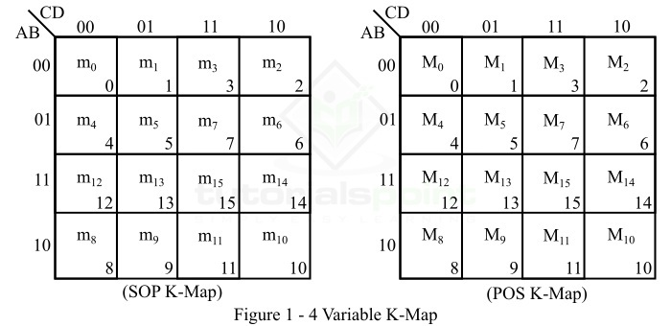
Here, the binary number designations of the columns and rows are in the Gray code. This is known as adjacent ordering. In these K-maps, the binary numbers along the left side of the map indicate the conditions of variables A and B along any row, and the binary numbers along the top of the K-map indicate the conditions of the variables C and D along any column. The decimal numbers in the bottom right corners of the cells indicate the minterm or maxterm designation.
Now, let us consider an example to illustrate the utilization of the 4 variable K-map for simplification of a Boolean function.
Example 1
Simplify the following Boolean expression using the 4-variable K-map.
f⟮A,B,C,D⟯=∑m⟮2,3,6,7,8,10,13,15⟯
f⟮A,B,C,D⟯=∑m⟮2,3,6,7,8,10,13,15⟯
Solution
The SOP K-map representation of the given Boolean function is shown in Figure 2.
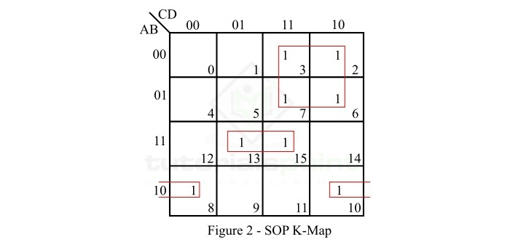
Explanation
The simplification of the function is done as per the following steps −
There are no isolated 1s in the K-Map.
The minterm m2 can form a 4-square with m3, m6, and m7. Make it and read it as −
A¯C()A¯C()
The minterm m8 can form a 2-square with m10. Make it and read it as −
ABD¯()ABD¯()
The minterm m13 can form a 2-square with m15. Make it and read it as −
(AB¯D)(AB¯D)
Write all the product in SOP form.
So the simplified SOP expression is,
f(A,B,C,D)=A¯C+AB¯D+ABD¯f(A,B,C,D)=A¯C+AB¯D+ABD¯
Example 2
Minimize the following Boolean expression using the 4-variable K-map.
f(A,B,C,D)=∏M(4,6,11,14,15)f(A,B,C,D)=∏M(4,6,11,14,15)
Solution
The POS K-map representation of the given Boolean function is shown in Figure 3.
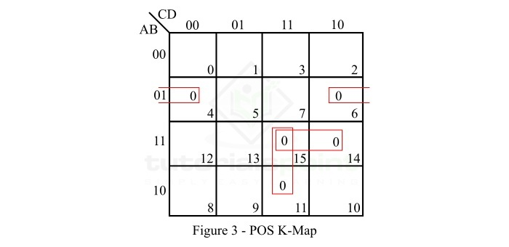
Explanation
In minimization of the given function is done as per the following step −
There are no isolated zeros in the K-map.
The maxterm M4 can form a 2-squate with M6. Make it and read it as −
(A+B¯+D)(A+B¯+D)
The maxterm M11 can form a 2-square with M15. Make it and read it as −
(A¯+C¯+D¯)(A¯+C¯+D¯)
Now, only maxterm M₁₄ is left. M₁₄ can form 2-square with M₆ or M₁₅. If we make it with M15, then read it as −
(A¯+B¯+C¯)(A¯+B¯+C¯)
Finally, write all the sum terms in POS form.
So, the reduced POS expression of the given Boolean function is,
f(A,B,C,D)=(A+B¯+D)(A¯+C¯+D¯)(A¯+B¯+C¯)

